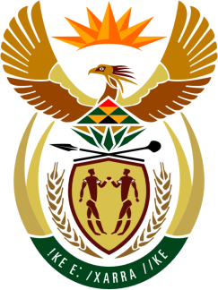

SOUTH AFRICAN PERMANENT MISSION

40th SESSION OF THE WORKING GROUP ON THE
UNIVERSAL PERIODIC REVIEW

Review of south sudan

31 JANUARY 2022
(09:00-12:30)

VIRTUAL (ZOOM PLATFORM)
(1 minute 15 sec)

Check against delivery

Mister President,

South Africa welcomes the Honourable Justice Ruben Madol Arol, Minister of Justice and Constitutional Affairs, and the distinguished delegation of the Republic of South Sudan to this UPR Session.

My delegation commends the progress made since the last review of South Sudan, inter alia, the reconstitution of the Transitional National Assembly, the appointment of the first female Speaker of Parliament and steps towards the establishment of transitional justice.

In the spirit of constructive dialogue, South Africa wishes to respectively recommend that South Sudan:

- Continue implementing the Revitalised Agreement on the Resolution of the Conflict in the Republic of South Sudan (the R-ARCSS);

- Expedite the establishment and the operationalisation of the Hybrid Court on South Sudan and the Commission on Truth, Reconciliation and Healing to ensure justice, accountability and healing.

South Africa wishes South Sudan a successful review.

I thank you, Mister President

