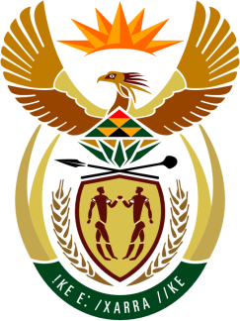

SOUTH AFRICAN PERMANENT MISSION

40th SESSION OF THE WORKING GROUP ON THE
UNIVERSAL PERIODIC REVIEW

Review of UGANDA

27 JANUARY 2022
(09:00-12:30)

VIRTUAL (ZOOM PLATFORM)
(65 seconds)

Check against delivery

Mister President,

South Africa welcomes the Honourable Odongo Jeje Abubakhar, Minister of Foreign Affairs and the distinguished delegation of Uganda to this UPR Session.

My delegation welcomes the Government’s efforts to strengthen oversight mechanisms, including the Ugandan Human Rights Commission, the Equal Opportunities Commission, and the Parliamentary Committees on Human Rights and Equal Opportunities.

In order to ensure progress in promoting and protecting human rights, South Africa wishes to respectively recommend that Uganda:

- Continues to strengthen measures in combating violence against women and girls and provide legal protection for victims of sexual and gender-based violence; and

- Enhances measures to prevent discrimination against all vulnerable groups, including women, children and persons living with HIV.

South Africa wishes Uganda a successful review.

I thank you.

