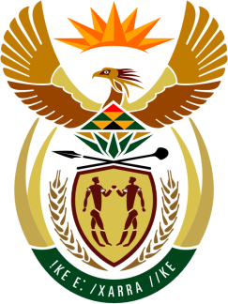

SOUTH AFRICAN PERMANENT MISSION

40th SESSION OF THE WORKING GROUP ON THE
UNIVERSAL PERIODIC REVIEW

Review of THE REPUBLIC OF ZIMBABWE

26 JANUARY 2022
(09:00-12:30)

VIRTUAL (ZOOM PLATFORM)

Check against delivery

(64 seconds)

Mr. President,

South Africa welcomes the Honourable Minister of Justice, Legal and Parliamentary Affairs, Mr Ziyambi ZIYAMBI and the distinguished delegation of the Republic of Zimbabwe to this UPR Session.

In order to ensure progress in promoting and protecting human rights, South Africa wishes to respectively recommend that Zimbabwe:

- Ensures the alignment of the Zimbabwe Human Rights Commission Act with the Paris Principles and the Constitution of Zimbabwe, and provide funding, for the protection and promotion of Human Rights.

My delegation welcomes the Government’s considerable progress in the alignment of laws to the Constitution that came into effect in 2013, and its commitment to the implementation of thereof. We further welcome the ratification, in 2019, of the African Charter on Democracy, Elections and Governance.

South Africa wishes Zimbabwe a successful review.

I thank you.

