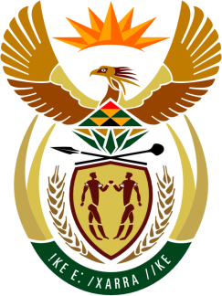

SOUTH AFRICAN PERMANENT MISSION

40th SESSION OF THE WORKING GROUP ON THE
UNIVERSAL PERIODIC REVIEW

Review of THE REPUBLIC OF TOGO

24 JANUARY 2021
(09:00-12:30)

VIRTUAL (ZOOM PLATFORM)
(74 seconds)

Check against delivery

Mr. President,

South Africa welcomes the Honourable Minister of Human Rights, Dr. Christian Trimua, and the distinguished delegation of the Republic of Togo to this UPR Session.

My delegation welcomes the Government’s efforts and commitment to improving the enjoyment of economic and social rights, since its previous passage of the UPR.

In order to ensure progress in promoting and protecting human rights, South Africa wishes to respectively recommend that Togo:

- Continue its actions with a view to strengthening measures for the protection and promotion of children, in particular young girls; incl. with regards to child labour and child marriage.

- Fully implement the provisions of the Convention against Discrimination in Education, which it had ratified; and enshrine the principle of non-discrimination in Ordinance No. 75-016 (of 6 May 1975), and revise the Ordinance to progressively guarantee 12 years of free, publicly funded primary and secondary education.

- Ensure that sufficient funds are allocated to HIV / AIDS education in secondary schools strengthening preventive action with young people and targeting adolescents from the most vulnerable groups.

South Africa wishes Togo a successful review.

I thank you.

