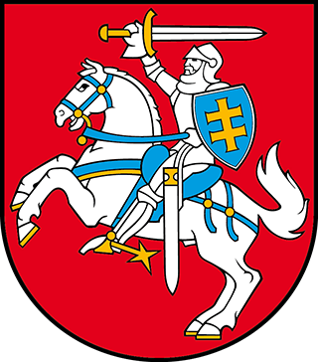

Closing statement by the Head of the Lithuanian Delegation
Ms. Jurga Greičienė, Vice-Minister of Justice, Ministry of Justice of the Republic of Lithuania
at the 40th session of the Working Group on the Universal Periodic Review of the United Nations Human Rights Council
26 January 2022

Madam Vice-President, Distinguished Delegations, Members of Civil Society,

I avail myself of this moment to share our gratitude for giving us this opportunity to take part in a constructive dialogue in-person, here, in Geneva.
Lithuania views this demanding experience as an opportunity to learn and improve legislation and practices to comply with the highest standards of protection of human rights. We are confident that the recent achievement we have shared with you during this session prove that we are on the right path.
Thank you for this interactive dialogue. Because of the limited time we could not possibly respond to all the questions raised by the distinguished delegations of the member states at length. But I assure you that we took good notice of your remarks, observations and suggestions.
All the comments and recommendations will be of a great value for the work ahead in taking further steps to ensure full respect and fulfilment of our international obligations relating to human rights.
I would like to thank distinguished Troika members as well as the UPR Secretariat for the facilitation of this process. Last but not least, let me thank the interpreters for their excellent work.
Thank you.

