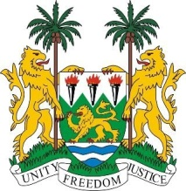
SIERRA LEONE
39th Session of the UPR

HUNGARY

STATEMENT BY SIERRA LEONE

2 November 2021

Madam Vice President,

Sierra Leone warmly welcomes the high-level delegation of Hungary and thanks them for their report presented today. We thank Hungary for its active engagement with the Council and other special procedure mandate holders.

My delegation recognised that since its last review, Hungary has made important strides with its fundamental law. We note specifically the New Civil Procedure Act, the Criminal Procedure Act, Code of Administrative Court Procedure among others. We welcome other laudable achievements such as the development of the nursery system, family tax allowance, child care fee, and the family house programme. We note the various measures taken to return mothers to the labour market.

My delegation further applauds Hungary for committing to promote minority rights, the rights of person with disabilities, family and children`s rights.

My delegation urges Hungary to adopt a human rights-based approach in tackling the current migration crisis within its borders and repeat it call for Hungary to protect the human rights and fundamental freedoms of all persons particularly migrants and those seeking asylum as guaranteed by the Equal Treatment Act

In a constructive spirit, Sierra Leone recommends the following:

- Ratify the ICPPED.
- Ease restrictions on civil society organisations using foreign funding.
- Take concrete measures to end poverty.
- Promulgate laws aimed at increasing women`s participation in governance.

Sierra Leone wishes Hungary a successful UPR.

Thank you, Madam Vice President.

