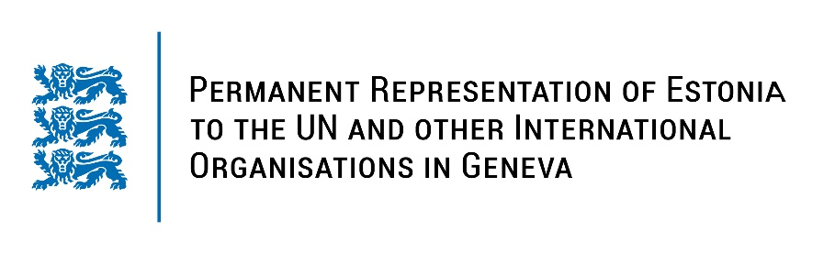
Universal Periodical Review of the Kingdom of Thailand
10 November 2021
Intervention by the delegation of Estonia

Estonia welcomes the delegation of the Kingdom of Thailand to the UPR’s 39th session.

Estonia commends Thailand for toughening penalties against child labour and encourage the government to provide adequate resources to fully implement child protection laws, particularly at the community level. We also encourage Thailand to step up efforts to fight against gender-biased and domestic violence.

Estonia would like to recommend Thailand:

- to accede to the Rome Statute of the International Criminal Court (ICC) and implement it into national legislation;
- to ratify the Agreement on Privileges and Immunities of the Court (APIC);
- to speed up the ratification process of the International Convention for the Protection of All Persons from Enforced Disappearance (ICPPED) and other core International human rights conventions;
- to remove the broad range of restrictions on the rights to peaceful assembly and freedom of expression;
- to abolish the death penalty.

We would like to wish the delegation of Thailand a successful review meeting.

I thank you!

