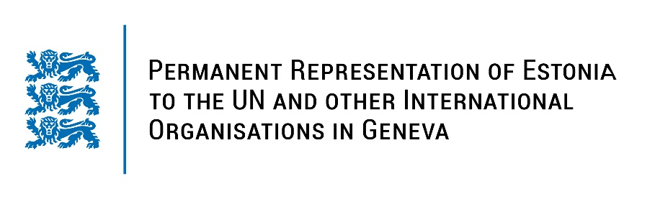
Universal Periodical Review of the Kingdom of Eswatini
8 November 2021
Intervention by the delegation of Estonia

Estonia welcomes the delegation of the Kingdom of Eswatini to this UPR session.

Estonia notes with appreciation that Eswatini has accepted several recommendations under UPR2 to combat discrimination against women, including adoption of the Sexual Offences and Domestic Violence Act (SODVA). Estonia encourages Eswatini to work further on fighting the violence against woman and children and fully implement SODVA.

We encourage the authorities to initiate a transparent, thorough, independent and impartial investigation into the allegations of human rights violations committed during the June 2021 protests and hold the perpetrators accountable.

Estonia would like to recommend to the Government of Eswatini to:
- intensify the reform of the judicial system;
- implement constitutional protections to ensure the independence of the judiciary and Parliament;
- accede to the Rome Statute of the International Criminal Court (ICC) and implement it into national legislation;
- prohibit all corporal punishment at home, alternative care settings, day care, schools and penal institutions;
- ensure the freedom of assembly, association and expression, including media freedom, online and offline.

Estonia would like to wish the delegation of Eswatini a successful review meeting.

I thank you!

