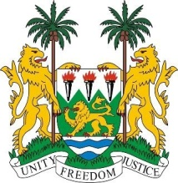
SIERRA LEONE
39th Session of the UPR

THAILAND

STATEMENT BY SIERRA LEONE

10 November 2021

Madam Vice President,

Sierra Leone welcomes the delegation of the Kingdom of Thailand and thanks them for their report presented this morning. We thank Thailand for its engagement with the council and notes the need for more cooperation with all special procedure mandate holders .

My delegation welcomes the many achievements made by Thailand since its last review. We note in particular, the ambitious constitutional provision that provides for a 20year (2018-2037) National Strategy for national development with a view to enhancing the country`s stability and sustainability.

My delegation applauds Thailand for establishing the National Human Rights Commission in conformity with the Paris principle. We welcome the country`s steps taken to alleviate poverty and calls for resilience in the face of the covid 19 pandemic.

In a constructive dialogue, Sierra Leone makes the following recommendations:

- Expedite the process of returning the NHRCT to level A status.
- Consider to ratify the Convention Relating to the Status of Refugees and the 1967 Protocol thereto.
- Take concrete measures to guarantee civil society space.

Sierra Leone wishes the Kingdom of Thailand a successful UPR.

Thank you, Madam Vice President.

