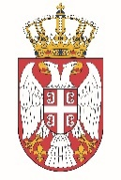

Permanent Mission of the Republic of Serbia to the United Nations Office in Geneva

Working Group for UPR
Interactive Dialogue on Report of United Republic of Tanzania
November 2021

The Republic of Serbia welcomes the participation of the delegation of the United Republic of Tanzania at the UPR’s Session and thanks for presenting the National Report.

Serbia appreciates greatly the level of commitment of Tanzania to the UPR process. We welcome in particular its dedication to the human trafficking issue and in this context the adoption of the National Anti-Trafficking Action Plan of 2018.

We would like to recommend to Tanzania to continue the fight against all forms of discrimination against women.

Serbia wishes Tanzania a successful review process.

