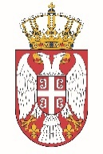

Permanent Mission of the Republic of Serbia to the United Nations Office in Geneva

Working Group for UPR
Interactive Dialogue on Report of Samoa
November 2021

The Republic of Serbia welcomes the delegation of Samoa and thanks the head of delegation for presenting the UPR National Report.

Serbia appreciates the efforts shown by the authorities of Samoa in fulfilling the obligations coming from the UPR process in the previous period. Serbia in particular welcomes the measures Samoa’s authorities has taken in providing adequate standards of living, including for the most vulnerable categories of people.

In spirit of a constructive dialogue, we would like to recommend to Samoa to further improve health care, especially for women in rural areas.

Serbia wishes Samoa a fruitful review process.

