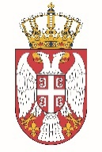

Permanent Mission of the Republic of Serbia to the United Nations Office in Geneva

Working Group for UPR
Interactive Dialogue on Report of Papua New Guinea
November 2021

The Republic of Serbia welcomes the participation of the delegation of Papua New Guinea at the UPR’s Session.

Serbia wishes to encourage Papua New Guinea to cooperate closely with the relevant UN bodies, including Human Rights Council. We welcome in particular the decisions of the authorities on ratifying conventions recommended during the last cycle.

We would like to recommend to Papua New Guinea to continue financing and supporting special measures that would remove all obstacles to women's political participation.

Serbia wishes Papua New Guinea a successful review process.

