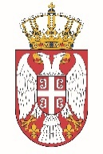

Permanent Mission of the Republic of Serbia to the United Nations Office in Geneva

Working Group for UPR
Interactive Dialogue on Report of Eswatini
November 2021

The Republic of Serbia welcomes the participation of the delegation of Eswatini at the UPR’s Session and thanks for presenting the National Report.

Serbia appreciates greatly the level of commitment of Eswatini to the UPR process. We welcome in particular its dedication to the anti-discrimination policy and the concrete legislative and institutional measures.

We would like to recommend to Eswatini to invest additional efforts to improve the system of protection of women in need by establishing shelters or temporary accommodation and educational centres for women in need, and their economic empowerment.
Serbia wishes Eswatini a successful review process.

