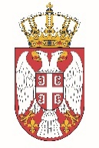

Permanent Mission of the Republic of Serbia to the United Nations Office in Geneva

Working Group for UPR
Interactive Dialogue on Report of Antigua and Barbuda
November 2021

The Republic of Serbia welcomes the delegation of Antigua and Barbuda at the UPR’s Session and thanks for presenting the National Report.

Serbia commends the all the efforts of Antigua and Barbuda invested to meet the recommendations of the UPR process, which shows a commitment to the improvement of the situation of its citizens. We welcome in particular measures taken by the authorities aimed at mitigating the impacts of COVID-19.

We would like to recommend to Antigua and Barbuda to seek to conduct a comprehensive assessment of budgetary needs for children and to increase allocation of financial means to social sectors, education and health to an adequate level.
Serbia wishes Antigua and Barbuda a successful review process.

