[Check against delivery]

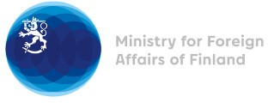

39 Session of the UPR working group Recommendations by Finland to Greece

1 November 2021

Finland highly appreciates the engagement of Greece in the UPR process and commends Greece for the progress made in its migration policy. Finland wishes to recommend the following:

- Firstly, to ensure adequate living conditions and access to services for refugees, asylum-seekers and irregular migrants in reception facilities, with particular attention to those in vulnerable situations.

- Secondly, to implement concrete measures to raise public awareness on women’s rights, including by offering training for judges, prosecutors, police officers, health-service providers and school staff, in order to ensure women’s rights fully in all areas of public life.

Thank you.

