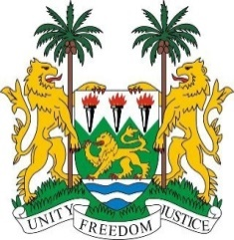
SIERRA LEONE
39th Session of the UPR (1-12 November 2021)

UPR Review of Tanzania

5 November 2021

Madam President,
Sierra Leone warmly welcomes the delegation of the United Republic of Tanzania to the third cycle UPR and thanks it for the presentation of the national report.
My delegation commends the government for developing the National Human Rights Action Plan, Judiciary Strategic Plan and the Legal Aid Act of 2017, and the National Plan of Action on Violence against Women and Children.
Sierra Leone particularly welcomes various steps taken to ensure equitable access to education, and the establishment of guidelines for supporting victims of trafficking and an anti-trafficking secretariat. We also note with interest that Tanzania’s national human rights institution has retained its Status “A” accreditation which is a testament of its autonomy and independence.
In a constructive spirit, Sierra Leone makes the following recommendations:
- Establish an official moratorium on executions with a view to abolishing the death penalty
- Ratify and accede to the CAT and ICPPED
- Consider to request technical assistance with a view to submitting overdue reports to the Committees of the ICESCR, CEDAW and CRPD
- Enhance efforts to combat all forms of gender- based violence against women, including domestic and sexual violence
- Enhance national infrastructure for the effective implementation of the National Human Rights Action Plan

We wish Tanzania every success with this UPR cycle
I thank you

