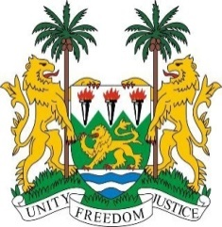
SIERRA LEONE
39th Session of the UPR (1-12 November 2021)

UPR Review of Ireland
10 November 2021

Madam President,
Sierra Leone warmly welcomes the delegation of Ireland to the third cycle of the UPR process and we thank them for their comprehensive national report.
My delegation commends the government on the important steps it has taken to address human rights issues since its last UPR, including ensuring the independence of the national human rights institution, improving access to justice, the establishment of human trafficking stakeholders’ forum, the roll-out of the Criminal Procedure Bill, and the ongoing financial contribution to the Office of the United Nations High Commissioner for Human Rights (OHCHR).
Furthermore, my delegation notes with appreciation that Ireland’s national human rights institution enjoys an “A” status accreditation.
However, we are concerned about increased reports of discrimination directed towards refugees, migrants, and people of African descent, particularly during the COVID-19 pandemic. In this context, we encourage Ireland to take positive steps to incorporate the International Convention on the Elimination of All Forms of Racial Discrimination into the domestic legal order.
While wishing Ireland a successful review, we recommend the following for their consideration:
- Ratify the OP-CAT and the ICPPED
- Take concrete steps to address discrimination and racism, particularly in the labour market, hate crime, and introduce legislation prohibiting ethnic profiling by the police
- Develop a new National Action Plan against Racism with clear indicators, timeframes, and resources
I thank you

