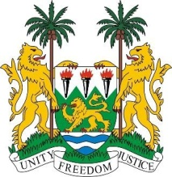
SIERRA LEONE
39th Session of the UPR

ESWATINI

STATEMENT BY SIERRA LEONE

8 November 2021

Mr. Vice President,

Sierra Leone welcomes His Excellency the Hon. Pholile Dlamini-Shakantu, Minister of Justice and Constitutional Affairs and the delegation of the Kingdom of Eswatini and thanks them for their report presented this morning. We thank Eswatini for its continued engagement with the council and trust that it will consider to issue standing invitation to all special procedure mandate holders.

My delegation notes with pleasure, the progressive strides taken by the Kingdom of Eswatini since its last review including the Education Policy that provides for the admission of pregnant girls and adolescent mothers to school. Given the tremendous toll Covid 19 has had on education, my delegation calls for concrete measures to mitigate the existing gap in the educational system. We regret that our recommendation to ratify and accede to the International Convention for the Protection of all Persons from Enforced Disappearance was noted.

In a constructive spirit, Sierra Leone makes the following recommendations:

- Ratify the OPCAT and the Maputo Protocol.
- Take steps to end extreme poverty particularly in the rural areas.
- Take concrete measures to guarantee civil and political rights including civil society and press freedom .
- Consider to review the King`s 1973 Decree on Political Parties.

Sierra Leone wishes the Kingdom of Eswatini a successful UPR.

Thank you, Mr. Vice President.

