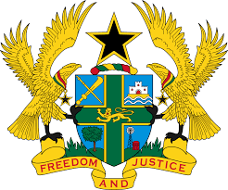

STATEMENT BY GHANA DELIVERED BY H.E. RAMSES JOSEPH CLELAND, AMBASSADOR AND PERMANENT REPRESENTATIVE,
FRIDAY, 5TH NOVEMBER, 2021

REVIEW OF THE UNITED REPUBLIC OF TANZ ANIA

Thank you, Madman President.
Ghana welcomes the delegation of the United Republic of Tanzania to the UPR Working Group and thank them for their report.
2. My delegation acknowledges the establishment of the National Anti-Trafficking Action Plan of 2018-2021 and the development of the National Strategy on Elimination of Child Labour (2018-2022) to reduce child labour.
3. We further commend the government for efforts to ensure women empowerment in all sectors and welcome the establishment of the Women Participation Unit in the Ministry of Works and Transport.
4. Ghana has the following recommendations:
- Continue to reinforce relevant measures to ensure the elimination of violence against women, including prohibition of all harmful practice such as Female Genital Mutilation ;
- Intensify its efforts to ratify outstanding International instruments, of note is the UN Convention against Torture and Other Cruel, Inhuman or Degrading Treatment or Punishment (UNCAT) and its optional protocol and;
- Ensures full respect for the right to freedom of expression by removing all
obstacles to the right to freedom of expression and media freedom.

We wish Tanzania a successful review outcome.

I thank you.

