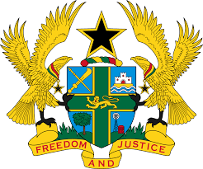

STATEMENT BY GHANA DELIVERED BY AKOSUA D. OKYERE BADOO,
DEPUTY PERMANENT REPRESENTATIVE, TUESDAY, 2ND NOVEMBER, 2021

REVIEW OF HUNGARY

Thank you, Madam President.

Ghana welcomes the delegation of Hungary to the UPR Working Group and we thank them for the presentation of their national report.
2. My delegation welcome the measures taken by the Government since their last UPR and welcome the measures taken to intensify equality between women and men by promoting women’s participation in the labour market as well as political level.
3. We encourage the Government to intensify the process towards the establishment of a National Action Plan on women and peace and security based on UN Security Council resolution 1325.
4. Ghana makes the following three recommendations:
- To ratify the International Convention on the Protection of the Rights of All Migrant Workers and Members of Their Families;
- Take measures to prevent and eliminate racism, racial
discrimination, xenophobia and bring the perpetrators to justice and lastly;
- Take further steps to eliminate discrimination against the Roma
population, especially in the field of education, health and employment.
Ghana wishes Hungary a successful review outcome

I thank you.

