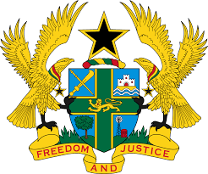

STATEMENT BY GHANA DELIVERED BY AKOSUA D. OKYERE BADOO,
DEPUTY PERMANENT REPRESENTATIVE,
MONDAY, 8TH NOVEMBER, 2021

REVIEW OF THE KINGDOM OF ESWATINI

Thank you, Madam President
Ghana welcomes the participation by the delegation of Kingdom of Eswatini to the UPR process.
We commend Eswatini for progress made since its previous UPR, including the establishment of several legislations to promote and protect human rights in the country. This includes the Sexual Offences and Domestic Violence Act 2018 and the Prevention of Organised Crime Act 2018. We further commend the efforts put in place to ensure the smooth and effective administrative of justice as well as fair trial in the country.
Ghana makes the following recommendations:
- Intensify its efforts to ratify outstanding International treaties and protocols, including the Optional Protocol to the Convention Against Torture (OP-CAT) and Optional Protocol to the Convention on the Elimination of all forms of Discrimination Against Women;
- Continue to reinforce relevant measures to promote and protect the rights to freedom of expression and rights to peaceful assembly;
- Take action to align all laws and policies with the principle of equality and non-discrimination as stated in the Constitution and in accordance with Convention on the Elimination of All Forms of Discrimination against Women (CEDAW) and;
- Strengthen efforts to ensure the implementation of the right to freedom of expression and peaceful assembly.

We wish Eswatini a successful review.

I thank you.

