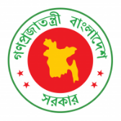
39th Session of UPR Working Group

Statement by Government of Bangladesh
Review of the 3rd Cycle of UPR of Ireland
(10 November 2021, 14:30-18:00 hrs.)

Madam President,
Bangladesh welcomes the distinguished delegation of Ireland in the 3rd cycle of UPR.

02. We appreciate Ireland for making further progress in the area of human rights since its second review.

03. Bangladesh recommends Ireland to:

One, strengthen efforts, including legislative mechanisms, to root out racism, racial discrimination and hate crimes.

Two, reinforce measures to address workplace discrimination and gender pay gap.

Three, take further steps to ensure non-discriminatory access to social housing by all ethnic minorities and migrants.

04. We wish Ireland a successful review.

I thank you.
***

