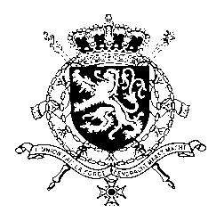
Représentation permanente de la Belgique auprès des Nations Unies et auprès des institutions spécialisées à Genève

WG UPR – Suriname
Belgian intervention
1 November 2021

Mr./Madam President,

Belgium acknowledges the progress made by Suriname since its previous UPR and especially welcomes the setting up of IKBeN, an integrated child protection network.

However, there is still room for progress, especially concerning the rights of children and women. Therefore, Belgium recommends to:

R1. Step up efforts for child protection by adopting regulatory instruments and policies and by providing the IKBeN network with adequate resources and assistance

R2. Implement a multisectoral policy approach, aiming at enhancing and guaranteeing the provision of professional gender-based violence services, especially in rural areas

R3. Provide access to safe and affordable contraceptives, family planning services and adequate information on sexual and reproductive health.

Thank you, Mr./Madam President.

