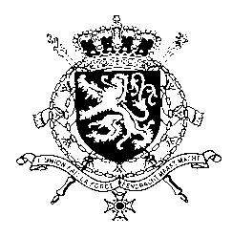
Représentation permanente de la Belgique auprès des Nations Unies et auprès des institutions spécialisées à Genève

WG UPR – Greece
Belgian intervention
1 November 2021

Mr./Madam President,

Belgium congratulates the government of Greece for the achievements and progress made since the second review, such as the ratification of the Istanbul Convention on Preventing and Combating Violence against Women and Domestic Violence and the European Social Charter.

In order to complement the efforts made, Belgium recommends to:

R1. Ratify the Optional Protocol to the International Covenant on Economic, Social and Cultural Rights;

R2. Enhance capacities of law enforcement authorities entrusted with investigating hate and racial crimes and to services in support of victims of such crimes;

R3. Ensure the full and effective implementation of the Convention on Preventing and Combating Violence against Women and Domestic Violence, inter alia by adopting the necessary secondary legislation and implementing decrees.
Thank you, Mr./Madam President.

