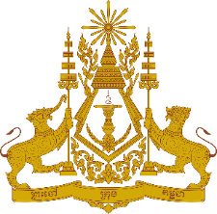
PERMANENT MISSION OF THE KINGDOM OF CAMBODIA
TO THE UNITED NATIONS AT GENEVA

Statement of Cambodia
At the 39th Session of the UPR Working Group
UPR of Hungary
02 November 2021
-------
Madam President!
- Cambodia recognizes Hungary’s substantial progress and achievements since its second UPR cycle. Hungary’s efforts for equality between women and men by promoting women’s participation in labor market, facilitating the return of mothers to the labor market, and substantially reducing the pay gap are commendable.

- We also recognize Hungary’s concrete initiatives to address domestic violence, and to significantly increase its ODA/GNI ratio to nearly 0.26% in 2020.

- In the constructive spirit, Cambodia would like to put forward three recommendations to Hungary:
- First, intensify further efforts toward implementation of the National Disability Program, increase in the number of children with disabilities attending the public education system, raise in employment rate of the persons with disability.
- Second, explore additional initiatives toward elimination of violence against women
- Third, consider further efforts toward early preparation of the National Action Plan based on UNSC Resolution 1325.

- Finally, I wish the delegation of Hungary every success in this exercise.

*****

