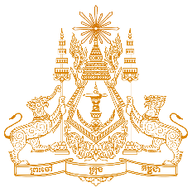
PERMANENT MISSION OF THE KINGDOM OF CAMBODIA
TO THE UNITED NATIONS AT GENEVA

Statement of Cambodia
At the 39th Session of the UPR Working Group
UPR of Ireland
11 November 2021
(Allocated time: 1 min 7 seconds)

Madam President,

- Cambodia appreciates Ireland’s unwavering commitment to promoting and protecting human rights. We acknowledge Ireland’s substantial progress in implementing recommendations from the previous cycle.
- My delegation welcomes Ireland’s enactment of various legislations and action plans aimed at combating GBV and addressing employment-related matters, including those of the PwDs.
- For Ireland’s continued progress, Cambodia would like to offer two recommendations:
- Broaden efforts to increase legal and financial aid in enabling the vulnerable, migrants and asylum seekers to fully access to justice and addressing their social welfare and equality issues
- Take additional steps to promote and protect rights of homeless children and those with special care, including offering enhanced flexibility in the education system and equality in health care delivery without discrimination.
- I wish the delegation of Ireland every success in this exercise.

Thank you!
*****

