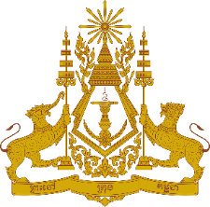
PERMANENT MISSION OF THE KINGDOM OF CAMBODIA
TO THE UNITED NATIONS AT GENEVA

Statement of Cambodia
At the 39th Session of the UPR Working Group
UPR of the Kingdom of Thailand
10 November 2021
-------
Madam President!

- Cambodia commends Thailand’s efforts and achievements in addressing impact of the Covid-19 pandemic upon most vulnerable groups.

- We congratulate Thailand for making substantial progress to achieve the highest attainable standard of physical and mental health, and to raise greater percentage of women in senior business leadership roles. Wide-ranging initiatives to promote and protect rights of children, elderly persons and migrant workers are commendable. Its investment in universal health coverage and health services delivery are recognized as a model country.

- In the constructive spirit, Cambodia would like to put forward two recommendations:

- Take additional steps to further protect and promote rights of all workers, including fishermen.
- Broaden the ongoing efforts and cooperation with other states and stakeholders to continue addressing human trafficking.

- Finally, I wish the delegation of Thailand every success in this exercise.

I thank you, Madam President!
*****

