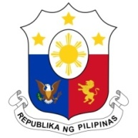
PHILIPPINES

HUMAN RIGHTS COUNCIL
39th Session of the Working Group on the Universal Periodic Review
5 November 2021, Palais des Nations, Geneva, Switzerland

UNITED REPUBLIC OF TANZANIA

Speaking Time: 1 min 10 sec
Speaking Order: 17 of 85

Thank you, Chair.

The Philippines warmly welcomes the delegation of Tanzania and thanks it for its national report.

We welcome Tanzania’s constructive approach to the UPR session and acknowledges the efforts made by the Government in the areas of poverty reduction and access to adequate standard of living.

In a constructive spirit, the Philippines presents the following recommendations for consideration by Tanzania:

- Continue to implement inclusive education programs including alternative learning opportunities for vulnerable groups;

- Strengthen gender mainstreaming in national and local development planning and ensure the participation of women and other relevant stakeholders in the process; and

- Take further proactive measures to prevent and address trafficking in persons and reduce the vulnerability of groups that are most at risk.

We wish Tanzania every success in this review cycle.

Thank you, Chair. END.

