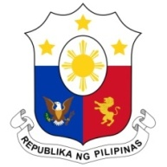
PHILIPPINES

HUMAN RIGHTS COUNCIL
39th Session of the Working Group on the Universal Periodic Review
02 November 2021, Palais des Nations, Geneva, Switzerland

SAMOA

Speaking Time: 2 min
Speaking Order: 6 of 58

Thank you, Chair.

The Philippines warmly welcomes the delegation of Samoa to this UPR session and thanks it for the presentation of its national report.

We acknowledge Samoa´s constructive approach to the UPR process and the progress made since the last review cycle.

The Philippines acknowledges the measures taken to mainstream human rights-based approach in development planning and in the implementation of the Sustainable Development Goals.

In a constructive spirit, the Philippines presents the following recommendations for consideration by Samoa:

- Further strengthen mechanisms to protect women and children from all forms of violence;

- Take steps to further enhance the participation of women in the political and public sphere; and

- Continue to enhance the involvement of vulnerable groups and affected stakeholders in climate change adaptation and mitigation efforts.

We wish Samoa every success in this review cycle.

Thank you, Chair. END.

