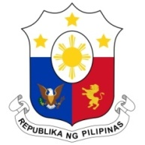
PHILIPPINES

HUMAN RIGHTS COUNCIL
39th Session of the Working Group on the Universal Periodic Review
02 November 2021, Palais des Nations, Geneva, Switzerland

HUNGARY

Speaking Time: 1 min 05 sec
Speaking Order: 87 of 101

Thank you, Chair.

The Philippines warmly welcomes the delegation of Hungary.

We recognize Hungary’s constructive approach to the UPR process and its engagements with the human rights mechanisms.

We acknowledge Hungary’s commitment to further strengthening human rights promotion and protection especially for vulnerable groups and are pleased to note the concrete steps taken in the areas of anti-trafficking and the rights of women and children.

In a constructive spirit, the Philippines presents the following recommendations for consideration by Hungary:

- Continue to mainstream human rights education in school curricula;

- Ensure an inclusive and multi-stakeholder approach to implementing measures to prevent and address anti-trafficking in persons; and

- Further intensify public awareness campaigns against domestic violence and ensure provision of adequate support for victims.

We wish Hungary every success in this review cycle.

Thank you, Chair. END.

