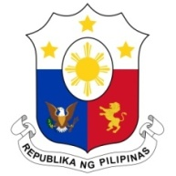
PHILIPPINES

HUMAN RIGHTS COUNCIL
39th Session of the Working Group on the Universal Periodic Review
8 November 2021, Palais des Nations, Geneva, Switzerland

ESWATINI

Speaking Time: 1 min 25 sec
Speaking Order: 52 of 83

Thank you, Chair.

The Philippines warmly welcomes the delegation of Eswatini and thanks it for the presentation of its national report.

We recognize Eswatini’s constructive approach to the UPR process and acknowledges the efforts made by the Government in advancing the human rights of vulnerable groups including women and persons with disabilities.

In a constructive spirit, the Philippines presents the following recommendations for consideration by Eswatini:

- Redouble efforts in conducting public awareness campaigns and capacity-building programs for duty bearers on gender-based violence and violence against children;

- Ensure allocation of sufficient resources to programs on combating trafficking in persons and provide adequate services to victims to support their reintegration and rehabilitation; and

- Further strengthen economic empowerment initiatives especially for women and youth.

We wish Eswatini every success in this review cycle.

Thank you, Chair. END.

