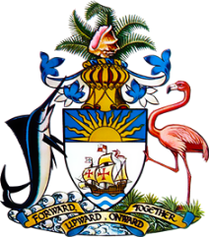

Statement by Ms. Kristie Russell, Third Secretary
Permanent Mission of The Bahamas to the United Nations Office and Other International Organizations in Geneva
at the 39th Session of the Universal Periodic Review Working Group
Presentation of National Report by the Government of the United Republic of Tanzania
5th November, 2021

The Bahamas extends a warm welcome to the delegation of the United Republic of Tanzania. We thank the delegation for its comprehensive report and also commend the delegation for its active and constructive engagement in this important process.
The Bahamas submits the following recommendations to Tanzania:

- ratify the UN Convention against Torture and other Cruel, Inhuman or Degrading Treatment and Punishment (UNCAT);
- end its policy of expelling pregnant school girls; and
- continue its efforts to curtail child labour.

We highlight the commitment of Tanzania to meeting its national, regional and international obligations towards the promotion, protection and realization of human rights.

We commend Tanzania for increasing the number of Safe Houses providing social welfare services to victims of violence.

We are also pleased with the enactment of the Legal Aid Act and its Regulations which provides greater access to justice.

We wish the delegation every success in this UPR process.

Thank you.

