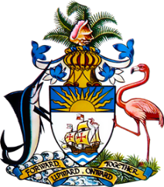

Statement by Mr. Frank Davis, Deputy Permanent Representative
Permanent Mission of The Bahamas to the United Nations Office and Other International Organizations in Geneva
at the 39thSession of the Universal Periodic Review Working Group
Presentation of National Report by the Government of Eswatini
Monday, 8 November, 2021

Thank you, Madam/Mr.[Vice] President.
The Bahamas extends a warm welcome to the delegation of Eswatini, thanks the country for its report and commends its engagement in this UPR process.
We commend Eswatini on enacting several pieces of legislation that domesticate the various human rights conventions ratified by the country as well as enactment of the Sexual Offences and Domestic Violence Act (2018) and the National Strategy and Action Plan to End Violence (2017-2022).
We also congratulate Eswatini for achieving the 95-95-95 HIV global target set for 2030.
In a constructive spirit, The Bahamas recommends that Eswatini:

- Advance efforts to finalize the drafted Strategy to address the increasing number of school dropout rates;
- Continue the initiatives Eswatini has implemented with the support of Development Partners to improve potable water supply and sanitation, especially in rural areas;
and
- Ratify the Convention Against Torture and Other Cruel, Inhuman or Degrading Treatment or Punishment

We recognise the challenges faced by Eswatini, including the strain that the coronavirus pandemic has put on progress towards national goals, the challenges faced by limited human resources and the disproportionate threats posed by climate change. We encourage Eswatini to avail itself of technical assistance and capacity-building support, in accordance with its human rights priorities and call on the international community to cooperate with the country in this regard.

We wish Eswatini every success in this UPR process.

I thank you.

