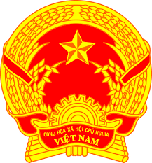
Statement of the Socialist Republic of Viet Nam
At the 39th Session of the UPR Working Group
Review of the Kingdom of Thailand
(Geneva, 10 November 2021, 9:00-12:30)

Delivered by H.E. Ms. LE Thi Tuyet Mai,
Ambassador and Permanent Representative of Viet Nam
to the United Nations Office in Geneva

Madam President,
Viet Nam welcomes the delegation of the Kingdom of Thailand and thanks it for the presentation of the national UPR report. Viet Nam commends the commitments and achievements by Thailand in the promotion and protection of human rights as well as its constructive engagement with the UPR mechanism.
In a constructive spirit, Viet Nam has two recommendations for Thailand:
- First, enhance measures to safeguard access to benefits, welfare, and social security for underprivileged and vulnerable groups.
- Second, continue proactive efforts to ensure that migrant workers can access rights as prescribed by applicable laws, including universal health coverage, access to information and proper documentation.
Finally, we wish Thailand every success in this UPR cycle.
I thank you, Madam President./.

