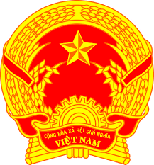
Statement of the Socialist Republic of Viet Nam
At the 39th Session of the UPR Working Group
Review of Ireland
(Geneva, 10 November 2021, 14:30-18:00)

Madam President,
Viet Nam highly welcomes the engagement of Ireland in the UPR process.
We commend the variety of steps that have been taken so far by Ireland since the last UPR in 2016 and offer the following recommendations to the Irish Government:
1. Take further steps to incorporate the International Convention on the Elimination of All Forms of Racial Discrimination into the domestic legal order, with a view to closing gaps in the policy and institutional framework for any group of people experiencing racial discrimination.
2. Intensify efforts to guarantee equal opportunities for women in the labour market and create more opportunities for women to gain access to
full-time employment.
Finally, we wish Ireland every success in this UPR cycle.
I thank you, Madam President./.

