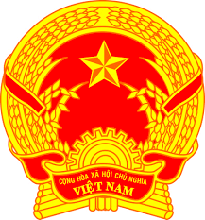
Statement of the Socialist Republic of Viet Nam
At the 39th Session of the UPR Working Group
Review of Hungary
(Geneva, 02 November 2021, 14:30-18:00)

Madam President,
Viet Nam warmly welcomes and thanks the delegation of Hungary for the presentation of the national report.
We commend the progress and the important development since the second UPR.
We took note of Hungary's voluntary pledge to pursue an active role in the Human Rights Council, in particular by promoting minority rights, the rights of persons with disabilities, family and children’s rights, freedom of religion and belief.
On this occasion, Viet Nam recommends that Hungary:
1. Adopt more policies and allocate more resources specifically directed towards equal education for all children.
2. Step up efforts to prevent discrimination against women and improve their life conditions.
We wish the Delegation of Hungary a successful review.
I thank you, Madam President./.

