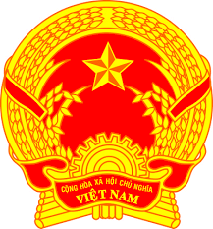
Statement of the Socialist Republic of Viet Nam
At the 39th Session of the UPR Working Group
Review of Greece
(Geneva, 01 November 2021)

Madam President,
Viet Nam thanks the delegation of Greece for the comprehensive presentation of the national UPR report.
Viet Nam welcomes Greece’s introduction of a comprehensive legal framework on gender equality and elimination of discrimination against women, which applies horizontally to all sectors of life. Viet Nam also welcomes the efforts of Greece to fight against domestic violence. Viet Nam takes note of the actions taken by Greece to promote and protect the rights of persons with disabilities and the rights of children.
In a spirit of constructive dialogue, Viet Nam would like to make the following recommendations to Greece:
1. Continue its efforts to effectively manage the mixed migration flows with full respect for rights of migrants.
2. Continue its efforts to combat human trafficking.
Viet Nam wishes Greece a successful review.
Thank you, Madam President./.

