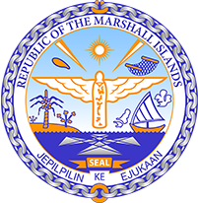

Republic of the Marshall Islands
STATEMENT by Mr. Samuel L. Lanwi Jr., Deputy Permanent Representative
39th Session, Universal Periodic Review
2 November 2021
Geneva
Hungary

Check against delivery

Thank you, Madam President,

The Marshall Islands welcomes the Delegation of Hungary to this UPR cycle and thanks them for their report.

We commend Hungary’s efforts to take up an active role in the Council and the interest in cooperating with different instruments and mechanisms of the Council.

Concerned about the impartiality and fundamental freedoms in Hungary and in the spirit of constructive engagement, the Marshall Island offer the following recommendations for Hungary’s consideration:

- Fully respect the separation of powers to ensure work will be exercised in an impartial and independent manner;
- Abolish the government bill declaring a “state of danger” in response to the COVID-19 pandemic; and
- Strengthen legislation and policies protecting against any forms of discrimination, especially discrimination against ethnic and sexual minorities as well as women.

We wish the delegation of Hungary all success during this UPR cycle.

Kommol tata and thank you

