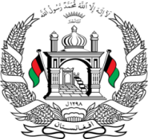
Permanent Mission of Islamic Republic of Afghanistan
Session of the UPR Working Group

Statement on the Review of Thailand

10th November 2021 at 09:00.

Mr./Mme. (Vice) President,

Afghanistan cordially welcomes the delegation of Thailand. We commend the positive developments since the 2nd cycle such as the adoption of the national action plan on business and human rights. We also welcome measures taken to ensure that migrant workers could access legal and social protections through regular migration status.

Mr./Mme. (Vice) President,

We express concern about the persistence of multiple barriers impeding women and girls from obtaining access to justice and effective remedies for violations of their right.

In the spirit of constructive engagement, we wish to make the following recommendations:

- Set up an independent mechanism for the prevention and suppression of torture and enforced disappearances, and that it reinforces the training of law enforcement officials and military,
- Expand social welfare initiatives to refugees and asylum seekers and that would allow them the right to work.

Finally, Afghanistan wishes Thailand every success in the review process.

I thank you, Mr./Mme. (Vice) President.

