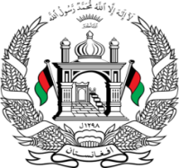
Permanent Mission of Islamic Republic of Afghanistan
Session of the UPR Working Group

Statement on the Review of Tajikistan

4 November 2021 at 14:30

Mr./Mme. (Vice) President,

Afghanistan warmly welcomes the distinguished delegation of Tajikistan to this meeting and thanks them for their engagement with the UPR.

We commend Tajikistan’s efforts for the implementation recommendations of the second cycle review. Afghanistan positively notes that several thematic action plans had been adopted, yet effective implementation of human rights obligations appears to be undermined by different factors.

Mr./Mme. (Vice) President,
In the spirit of constructive engagement, my delegation wishes to make the following recommendations:
- Develop internal regulations on refugee status determination, including terms of reference for the competent inter-ministerial commission, guaranteeing unhindered and fair access to asylum procedures,

- Ensure access to inclusive education for all persons with disabilities.

Finally, Afghanistan wishes Tajikistan every success in the review process.

I thank you, Mr./Mme. (Vice) President.

