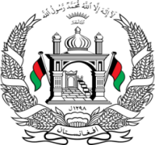
Permanent Mission of Islamic Republic of Afghanistan
Session of the UPR Working Group

Statement on the Review of Ireland

10th November 2021

Mr./Mme. (Vice) President,

Afghanistan cordially welcomes the Irish delegation. We commend the positive and important developments since the 2nd cycle such establishing Institutional framework for the protection of human rights in the name of the Irish Human Rights and Equality Commission.

Mr./Mme. (Vice) President,

We remain concerned about the lack of ratification of key human rights treaties, and Ireland’s failure to fully realize the human rights of refugees and asylum seekers.

In the spirit of constructive engagement, we wish to make the following recommendations:

- Ratify and the Optional Protocol to the Convention against Torture and Other Cruel, Inhuman or Degrading Treatment or Punishment.
- Adopt measures to improve the protection of refugees, migrants, and asylum seekers, by fully incorp orated into domestic law the 1951 Refugee Convention.

Finally, Afghanistan wishes Ireland every success in the review process.

I thank you, Mr./Mme. (Vice) President.

