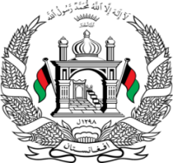
Permanent Mission of Islamic Republic of Afghanistan
Session of the UPR Working Group

Statement on the Review of Hungary

1st November 2021 at 09:00.

Mr./Mme. (Vice) President,

Afghanistan cordially welcomes the Hungarian delegation. We commend the positive developments since the 2nd cycle such as responding to the implementation of a National Strategy Against Trafficking.

Mr./Mme. (Vice) President,

We remain concerned about the breach of rights of stateless persons and the rights of refugees, in particular non-refoulement with a recent degree allowing Hungarian authorities to automatically push back asylum-seekers apprehended nears its borders, in the violation of European Community law and the principle of non-refoulement.

In the spirit of constructive engagement, we wish to make the following recommendations:

- Adopt measures to ensure the rights of every child to acquire nationality, with particular attention to those children who would otherwise be stateless.
- Adopt measures to ensure that an individual assessment is carried out for each case of asylum, deportation, or expulsion, with full respect for the principle of non-refoulement.

Finally, Afghanistan wishes Hungary every success in the review process.

I thank you, Mr./Mme. (Vice) President.

