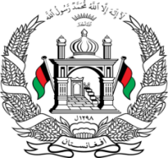
Permanent Mission of Islamic Republic of Afghanistan
Session of the UPR Working Group

Statement on the Review of Greece

1st November 2021 at 09:00.

Mr./Mme. (Vice) President,

Afghanistan cordially welcomes the Greek delegation. We commend the positive and important developments since the 2nd cycle such as responding to the legal recognition of gender identity, as well as the ratification of the Convention on Preventing and Combating Violence against Women and Domestic Violence.

Mr./Mme. (Vice) President,

We remain concerned about the breach of the principle of non-refoulement, with allegations of summary forced returns of asylum seekers and migrants.

In the spirit of constructive engagement, we wish to make the following recommendations:

- Adopt measures to ensure that an individual assessment is carried out for each case of asylum, deportation, or expulsion, with full respect for principles of non-refoulement;
- Ensure the meaningful participation of refugee and asylum-seeking women in decision- making on matters affecting their lives in the camps and that it monitors and review the health, safety and living conditions of refugees

Finally, Afghanistan wishes Greece every success in the review process.

I thank you, Mr./Mme. (Vice) President.

