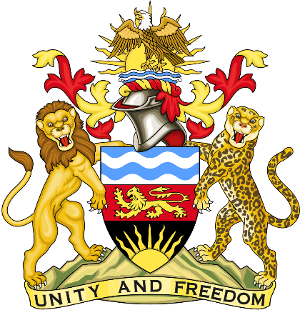

Statement delivered by Pacharo Kayira
Deputy Permanent Representative of the Republic of Malawi to the United Nations and other International Organisations in Geneva

39th Session of the Working Group of the Universal Periodic Review

Review of the Republic of Trinidad and Tobago

9 November 2021

Madam President.

Malawi welcomes the Republic of Trinidad and Tobago to this review and thanks the delegation for the presentation.

Malawi notes that Trinidad and Tobago is making progress to enhance the prison service following the recommendations it accepted in the second cycle review such as by improving hygiene and food quality for detained persons, expediting trials and eliminating crowding. We hope these measures will help the government to meet the United Nations Standard Minimum Rules for the Treatment of Prisoners, also known as the Nelson Mandela Rules.

In the spirit of constructive engagement, Malawi recommends the following to Trinidad and Tobago:

- Continue to improve conditions for prisoners and persons awaiting trial through further investment in infrastructure, training of personnel, and taking actions such as expanding judicial discretion to reduce bail terms and amounts for people accused of petty offenses.

- Consider acceding to the Convention against Torture and Other Cruel Inhuman or Degrading Treatment or Punishment.

- Consider acceding to the Convention for the Protection of All Persons from Enforced Disappearance.
Malawi wishes the Republic of Trinidad and Tobago a successful review.

Thank you, Madam President.

