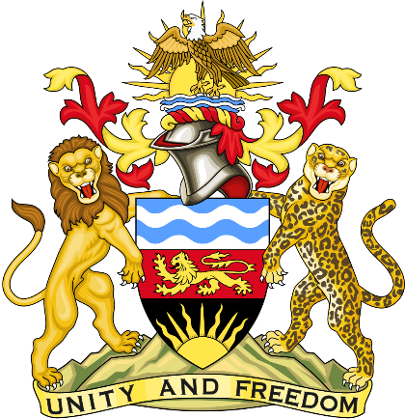

Statement delivered by Pacharo Kayira.
Deputy Permanent Representative of the Republic of Malawi to the United Nations and other International Organisations in Geneva

39th Session of the Working Group of the Universal Periodic Review

Review of the United Republic of Tanzania

5 November 2021

Madam President.

Malawi welcomes the United Republic of Tanzania, a friendly neighbour, to this review and thanks its delegation for the comprehensive report and presentation.

Malawi applauds the policy and legislative actions Tanzania has implemented to protect rights of children, such as the ongoing process to amend the Law of Marriage Act to increase the legal age, as well as to expand opportunities for quality education in the nation.

We note the great progress Tanzania has made to reduce poverty, combat corruption and improve infrastructure to anchor a firm foundation for development.

In the spirit of constructive dialogue, Malawi recommends the following to Tanzania:

- Complete the reforms necessary to raise the minimum legal age of marriage for boys and girls to 18 years and sensitise people on the importance of protecting the rights of all children.

- Continue efforts to reduce poverty, especially by enhancing access to quality education and skills development, as well as improving conditions for farming, small businesses and investors to thrive.

- Ratify the Convention against Torture and Other Cruel, Inhuman or Degrading Treatment or Punishment.

Malawi wishes the United Republic of Tanzania a successful review.

Thank you, Madam President.

