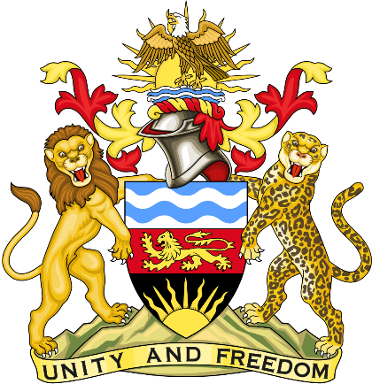

Statement delivered by Pacharo Kayira.
Deputy Permanent Representative of the Republic of Malawi to the United Nations and other International Organisations in Geneva

39th Session of the Working Group of the Universal Periodic Review

Review of the Kingdom of Thailand

10 November 2021

Madam President.

Malawi welcomes the Kingdom of Thailand to this review and thanks the delegation for the comprehensive presentation.

Malawi commends the progress Thailand has made to reduce teenage pregnancy and protect girls from exploitation while imparting life skills to them through national reproductive health policies. We also note efforts to increase awareness and reduce domestic violence through the Updated Model Strategies and Practical Measures on the Elimination of Violence against Women in the Field of Crime Prevention and Criminal Justice.

In the spirit of constructive dialogue, Malawi makes the following recommendations to Thailand:

- Continue to implement policies to raise awareness, prosecute perpetrators and adequately protect children and women from sexual exploitation and gender-based violence in conformity with the relevant national laws and international treaties to which the Kingdom of Thailand is a party.

- Improve the capacity of police, security forces and other law enforcement agencies to carry out their work while respecting the rights of people to freedom of assembly and expression, and civil society space.

- Consider acceding to the Convention for the Protection of All Persons from Enforced Disappearance.

Malawi wishes the Kingdom of Thailand a successful review.

Thank you, Madam President.

