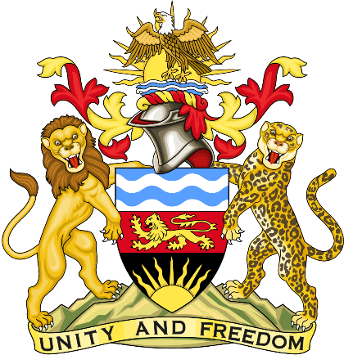

Statement delivered by Pacharo Kayira
Deputy Permanent Representative of the Republic of Malawi to the United Nations and other International Organisations in Geneva

39th Session of the Working Group of the Universal Periodic Review

Review of Republic of Tajikistan

4 November 2021

Madam President.

Malawi welcomes Tajikistan to this review and thanks its delegation for the presentation.

Malawi commends the progress Tajikistan has made to implement the Domestic Violence Prevention Act of 2013 through raising awareness, training law enforcement and health personnel and providing free medical care for victims of domestic violence and victims of trafficking through the Ministry of Health and Social Protection.

Malawi notes that Tajikistan established the State Policy Framework on Religion in April 2018 to guide protection of religious freedoms of all people and has taken measures to raise awareness and curb intolerance towards minority faiths.

In the spirit of constructive dialogue, Malawi recommends the following to Tajikistan:

- Sustain efforts to prevent domestic violence, support victims, and take legal action against perpetrators of domestic violence.

- Fully implement policies and laws for promoting tolerance, protecting religious rights and cultivating diversity.

- Complete ratification of the Convention on the Rights of Persons with Disabilities signed in March 2018, which process is not yet complete.

- Ratify the Convention for the Protection of All Persons from Enforced Disappearance.

Malawi wishes Tajikistan a successful review.

Thank you, Madam President.

