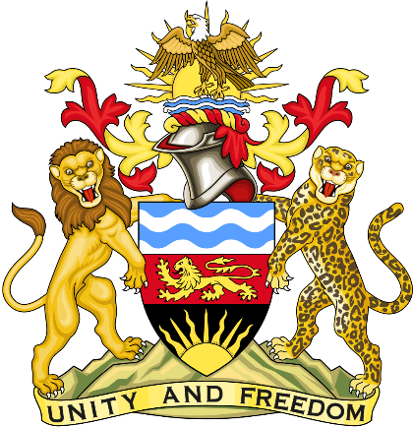

Statement delivered by Pacharo Kayira
Deputy Permanent Representative of the Republic of Malawi to the United Nations and other International Organisations in Geneva

39th Session of the Working Group of the Universal Periodic Review

Review of Suriname

1 November 2021

Thank you, Madam President.

Malawi welcomes Suriname to this review and thanks the delegation for the comprehensive presentation.

Malawi notes the important progress made by Suriname towards ratification of the Convention against Torture and Other Cruel, Inhuman or Degrading Treatment or Punishment, which is awaiting parliamentary approval. We also note that the Suriname Penal Code aims to enhance protection of children, men and women with severe penalties for human trafficking offenses.

Malawi makes the following recommendations to Suriname to advance constructive dialogue:

- Enforce the Penal Code more effectively to investigate and prosecute individuals and organised groups engaged in trafficking people for sexual and labour exploitation, with the maximum penalty of life imprisonment being sought in courts for egregious cases.

- Build the capacity of officials to improve identification and protection of victims of human trafficking.

- Complete the ratification of the Convention against Torture and Other Cruel Inhuman or Degrading Treatment or Punishment.

We wish Suriname success at this review.

Thank you, Madam President.

