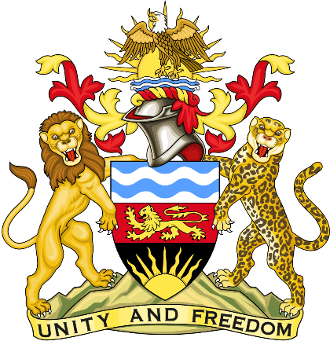

Statement delivered by Pacharo Kayira
Deputy Permanent Representative of the Republic of Malawi to the United Nations and other International Organisations in Geneva

39th Session of the Working Group of the Universal Periodic Review

Review of Samoa

2 November 2021

Thank you, Madam President.

Malawi welcomes Samoa to this review and thanks the delegation for the succinct presentation.

Malawi recognises that climate change affects small island as well as least developed nations disproportionately, compared to their minimal contribution to harmful emissions. Malawi therefore applauds the nation for adopting the Samoa Climate Change Policy 2020 to mitigate the impact, and the Samoa 2040 Strategy to guide sustainable national development.

Malawi makes the following recommendations to Samoa in the spirit of constructive dialogue:

- Take concrete steps to raise awareness, prevent as well as penalise gender-based violence, especially to protect women and children.

- Enhance legislative mechanisms and enforcement to prevent, disrupt and severely punish human trafficking for sexual and labour exploitation.

- Ratify the Convention on the Elimination of All Forms of Racial Discrimination and the Covenant on Economic, Social and Cultural Rights.

Malawi wishes Samoa a successful review.

Thank you, Madam President.

