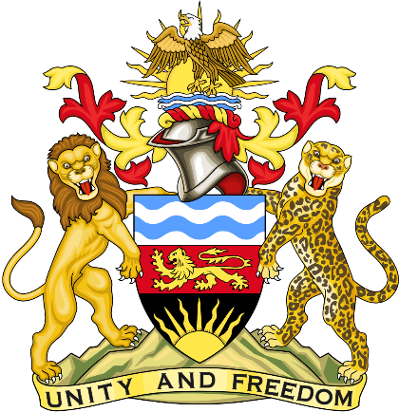

Statement delivered by Pacharo Kayira
Deputy Permanent Representative of the Republic of Malawi to the United Nations and other International Organisations in Geneva

39th Session of the Working Group of the Universal Periodic Review

Review of Saint Vincent and the Grenadines

3 November 2021

Thank you, Madam President.

Malawi welcomes Saint Vincent and the Grenadines to this review and thanks the delegation for the comprehensive presentation.

Malawi applauds Saint Vincent and the Grenadines for its response to the COVID-19 pandemic through implementation of the Recovery and Stimulus Package to give social assistance to people and amendment of the National Insurance Act to provide unemployment allowances. Malawi notes the effective response of Saint Vincent and the Grenadines to the catastrophic volcanic eruption in April 2021 through safe evacuation, housing and relief provisions for the more than 21 per cent of the population displaced by the disaster. Malawi recognises that Saint Vincent and the Grenadines needs the cooperation of the international community to mitigate the impact of the volcanic disaster on people.

Malawi makes the following recommendations to Saint Vincent and the Grenadines in the spirit of constructive dialogue:

- Implement policy measures to eliminate discrimination against women with regard to preventing and punishing gender-based violence and promoting equal representation of women in political, social and economic spheres as well as leadership.

- Improve capacity of officials and institutions to investigate, prosecute and severely punish human trafficking for sexual and labour exploitation.
- Conclude the ratification of the Convention for the Protection of All Persons from Enforced Disappearance.

Malawi wishes Saint Vincent and the Grenadines a successful review.

Thank you, Madam President.

